ASSIGNMENT-8.1
Batch-13
H NO:2303A51685

Task Description #1 (Password Strength Validator – Apply AI in Security Context)
- Task: Apply AI to generate at least 3 assert test cases for is_strong_password(password) and implement the validator function.
- Requirements:
o Password must have at least 8 characters. o Must include uppercase, lowercase, digit, and special character. o Must not contain spaces. Example Assert Test Cases:
assert is_strong_password("Abcd@123") == True assert is_strong_password("abcd123") == False assert is_strong_password("ABCD@1234") == True
Expected Output #1:
• Password validation logic passing all AI-generated test cases.
PROMPT:
Generate a Python function is_strong_password(password) that validates a password (minimum 8 characters, must include uppercase, lowercase, digit, special character, and no spaces) and provide 4 types of test cases: general test cases, assertion test cases, unittest test cases, and pytest test cases.

CODE
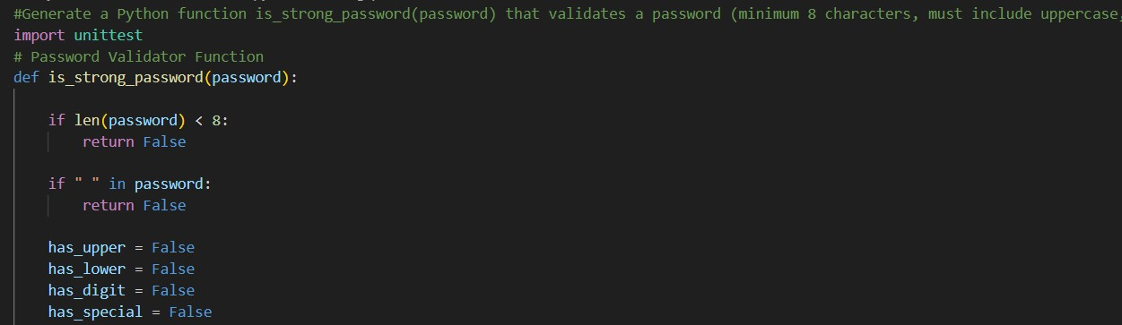
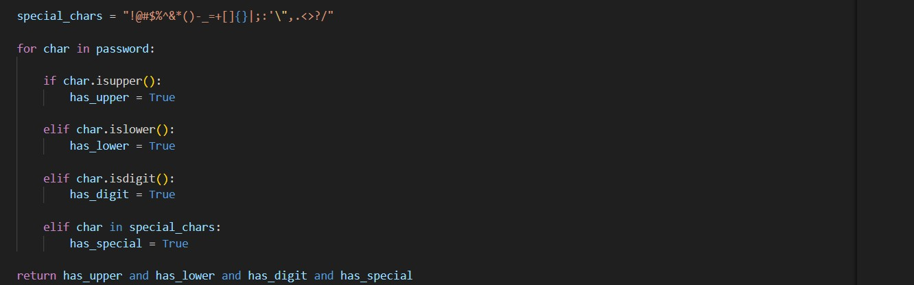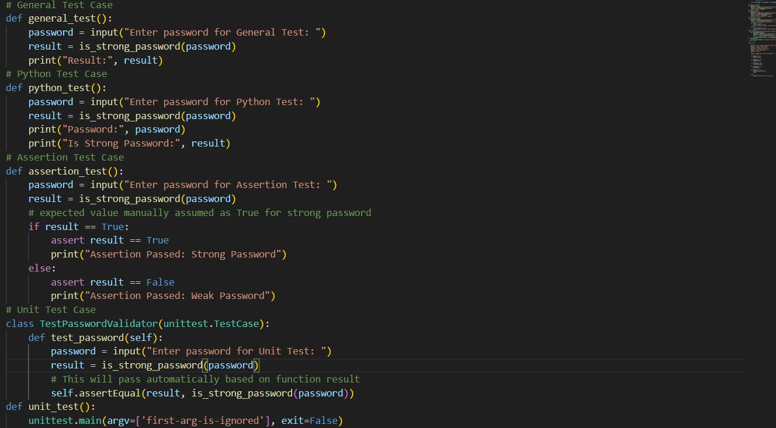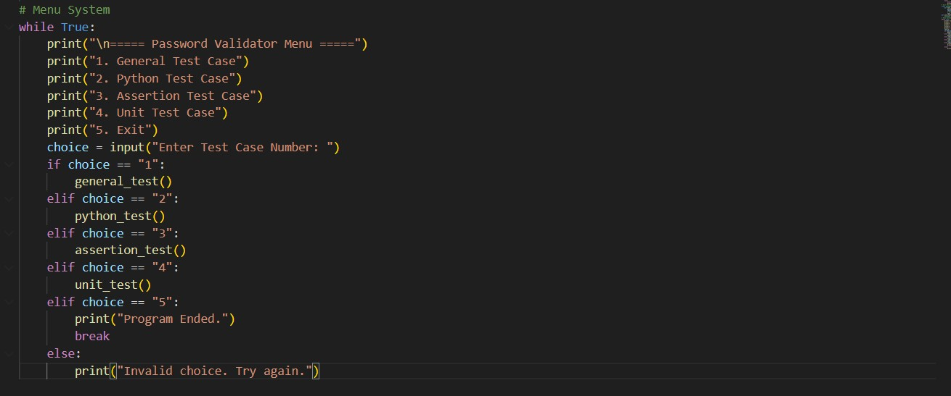

1.General Test Case
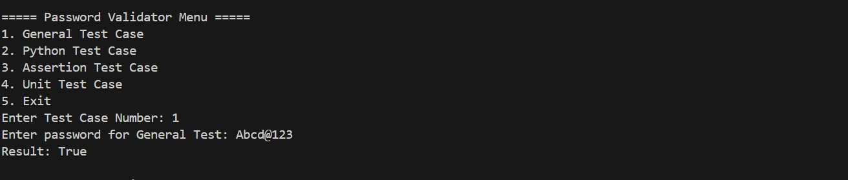

2.Assertion Test Case
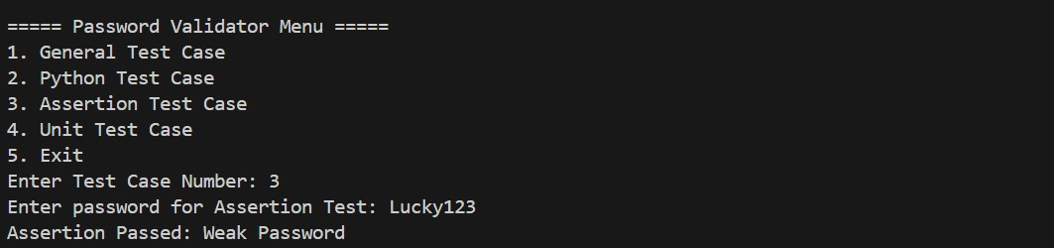

3.Unit Test Case
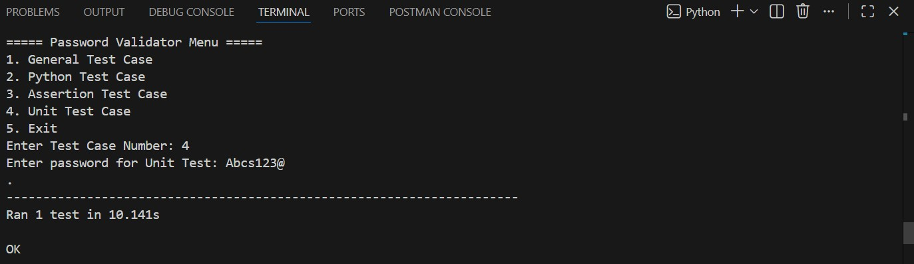

4.py test
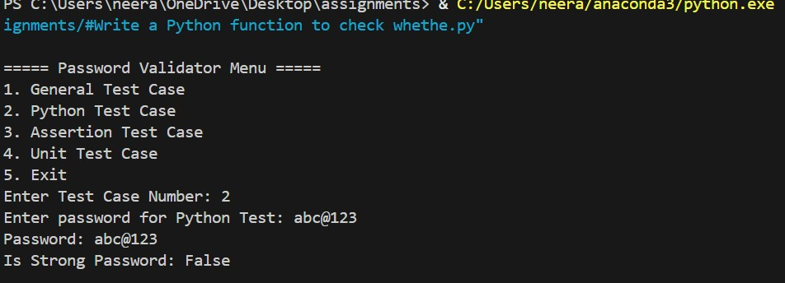

Task Description #2 (Number Classification with Loops – Apply AI for Edge Case Handling)
- Task: Use AI to generate at least 3 assert test cases for a classify_number(n) function. Implement using loops.
- Requirements:
o Classify numbers as Positive, Negative, or Zero. o Handle invalid inputs like strings and None. o Include boundary conditions (-1, 0, 1). Example Assert Test Cases:
assert classify_number(10) == "Positive" assert classify_number(-5) == "Negative" assert classify_number(0) == "Zero"
Expected Output #2:
• Classification logic passing all assert tests.
PROMPT:
Generate a Python function classify_number(n) using loops that classifies a number as "Positive", "Negative", or "Zero", handles invalid inputs like strings and None, includes boundary cases (-1, 0, 1), and provide at least 3 assert test cases that pass successfully.

CODE
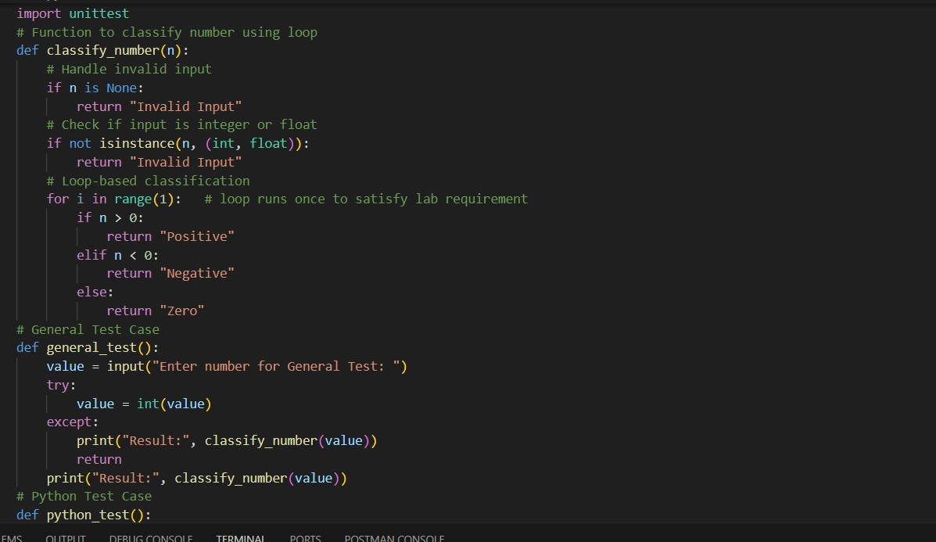
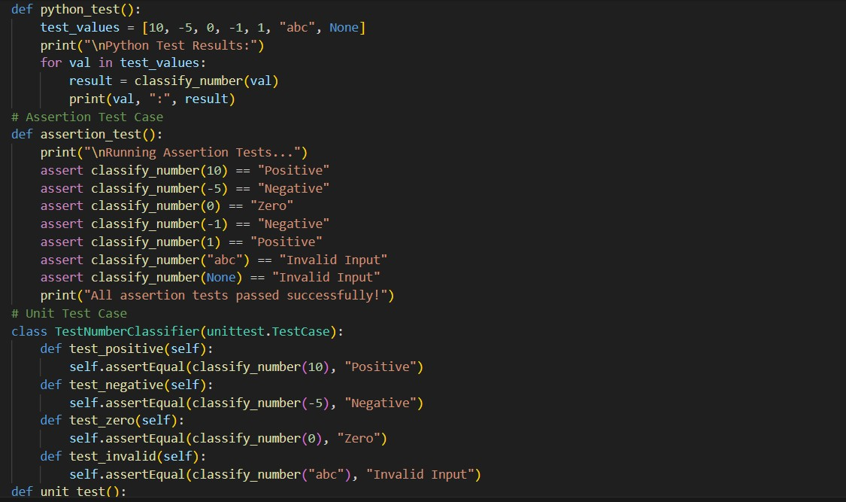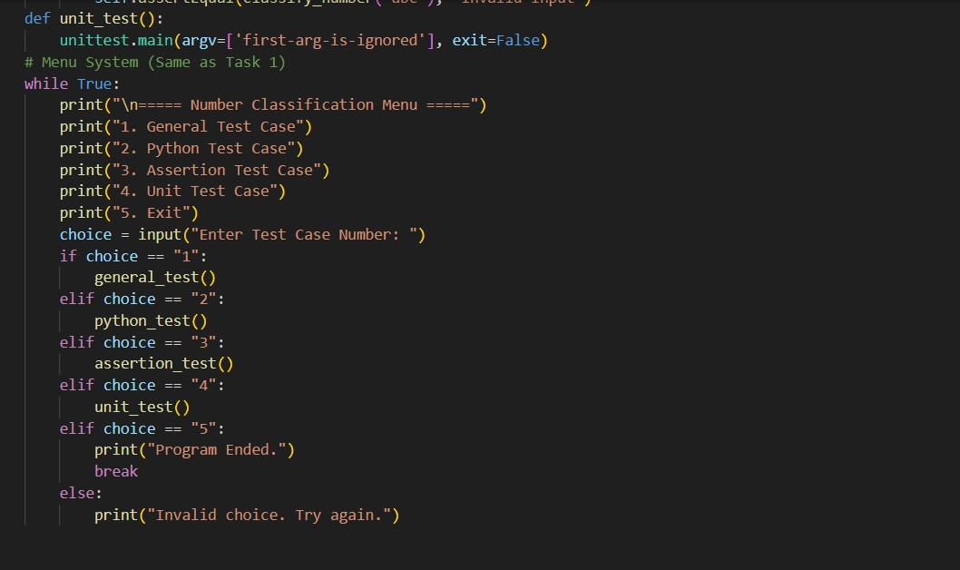

1.General Test Case
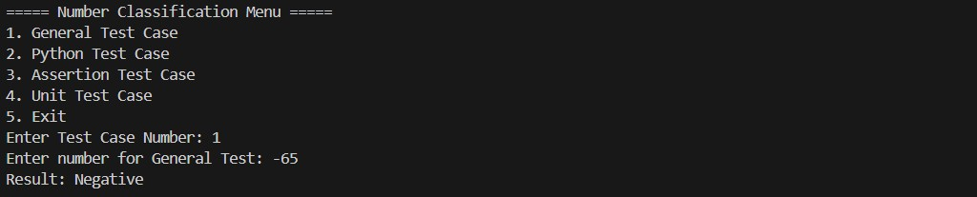

2.Assertion Test Case
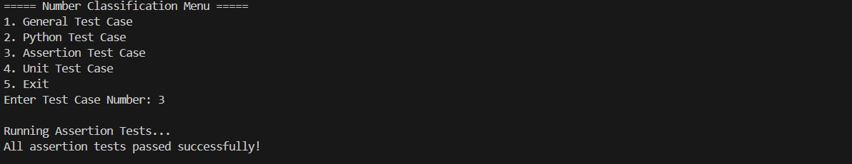

3.Unit Test Case
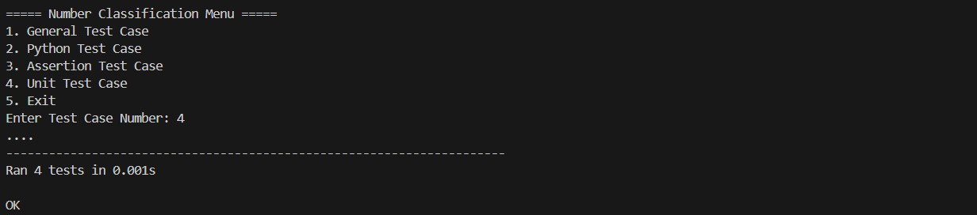

4.py test
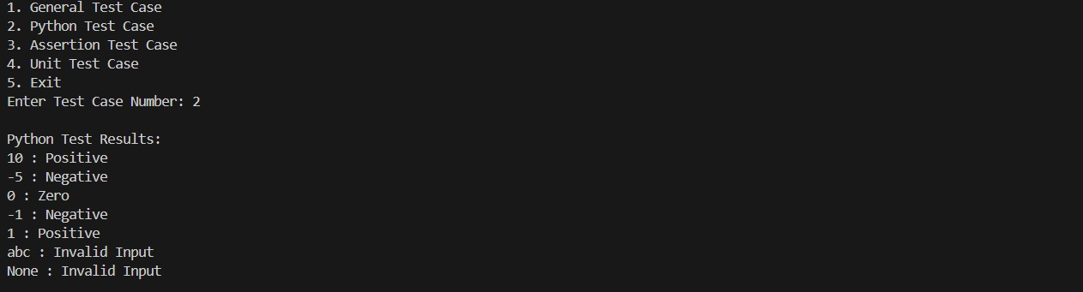

Task Description #3 (Anagram Checker – Apply AI for String Analysis)
- Task: Use AI to generate at least 3 assert test cases for is_anagram(str1, str2) and implement the function.
- Requirements:
- Ignore case, spaces, and punctuation.
- Handle edge cases (empty strings, identical words).
Example Assert Test Cases:
assert is_anagram("listen", "silent") == True assert is_anagram("hello", "world") == False assert is_anagram("Dormitory", "Dirty Room") == True
Expected Output #3:
• Function correctly identifying anagrams and passing all AI- generated tests.

PROMPT:
Generate a Python function is_anagram(str1, str2) that ignores case, spaces, and punctuation, handles edge cases like empty strings and identical words, and includes at least 3 assert test cases to verify the solution.
CODE:
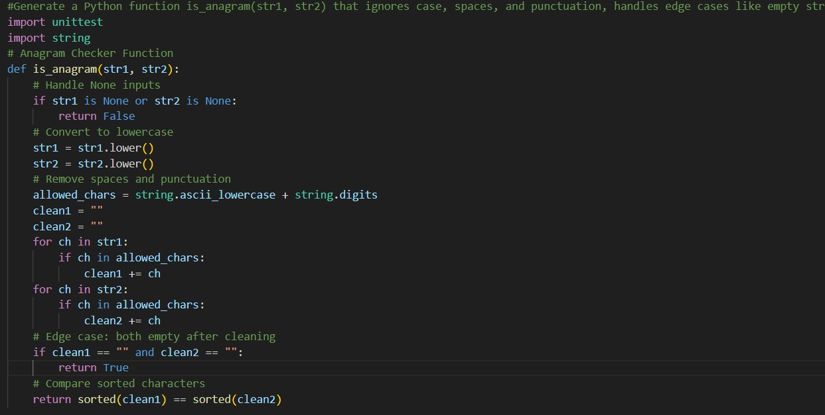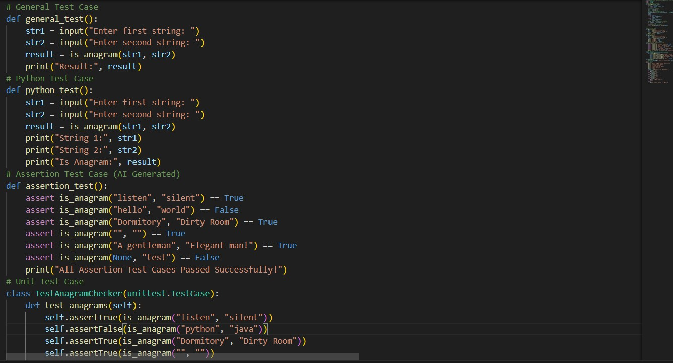
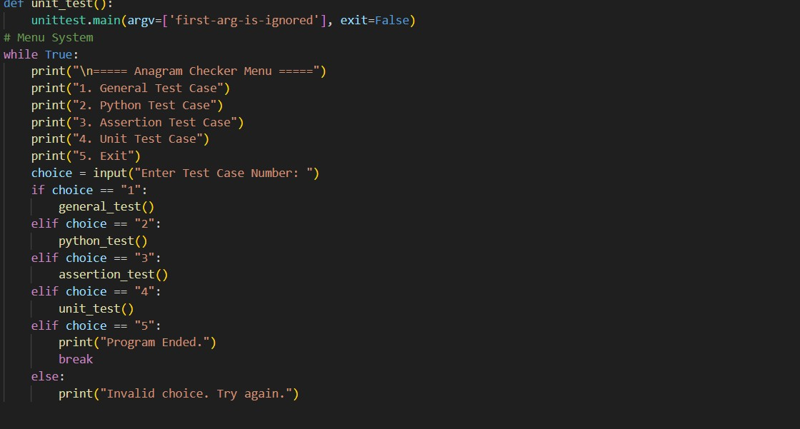

1.General Test Case
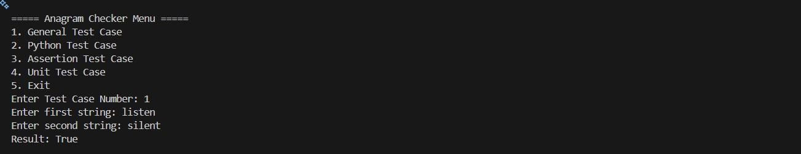

2.Python Test Case
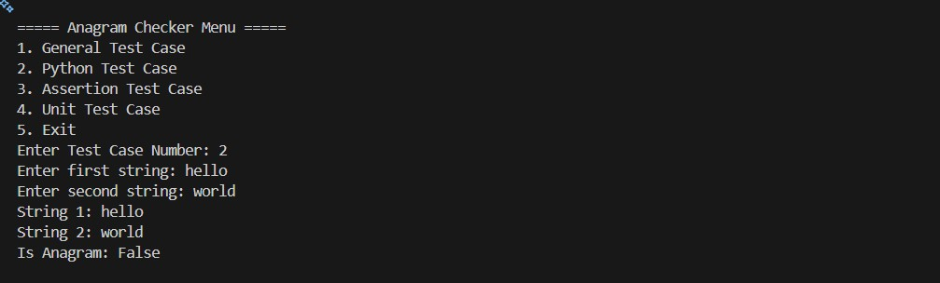

3.Assertion Test Case
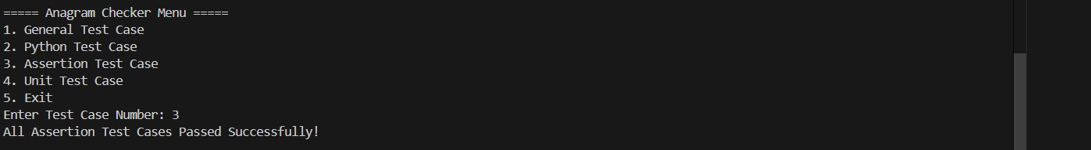

4.Unit test Case
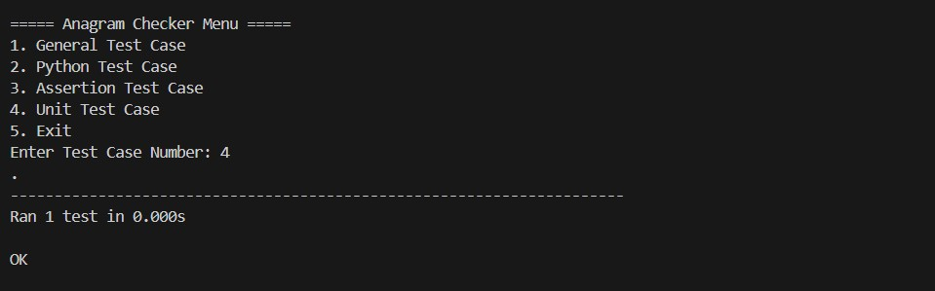

Task Description #4 (Inventory Class – Apply AI to Simulate Real- World Inventory System)
- Task: Ask AI to generate at least 3 assert-based tests for an Inventory class with stock management.
- Methods:
o add_item(name, quantity) o remove_item(name, quantity) o get_stock(name) Example Assert Test Cases: inv = Inventory() inv.add_item("Pen", 10) assert inv.get_stock("Pen") == 10 inv.remove_item("Pen", 5) assert inv.get_stock("Pen") == 5 inv.add_item("Book", 3) assert inv.get_stock("Book") == 3
Expected Output #4:
• Fully functional class passing all assertions.
PROMPT:
Generate a Python Inventory class with methods add_item(name, quantity),
remove_item(name, quantity), and get_stock(name), along with at least 3 assert-based test cases to verify correct stock management.

CODE
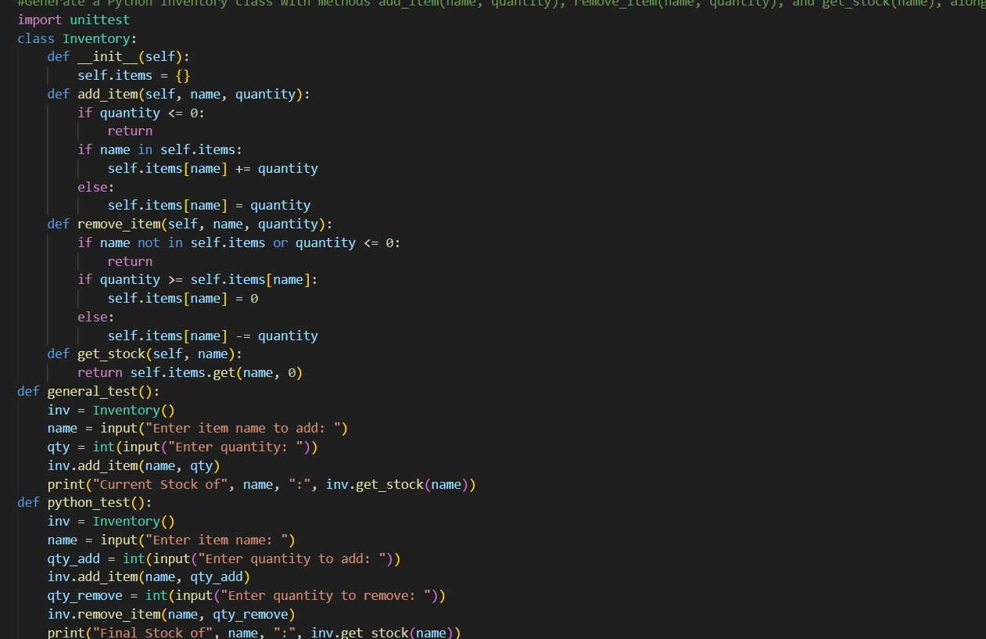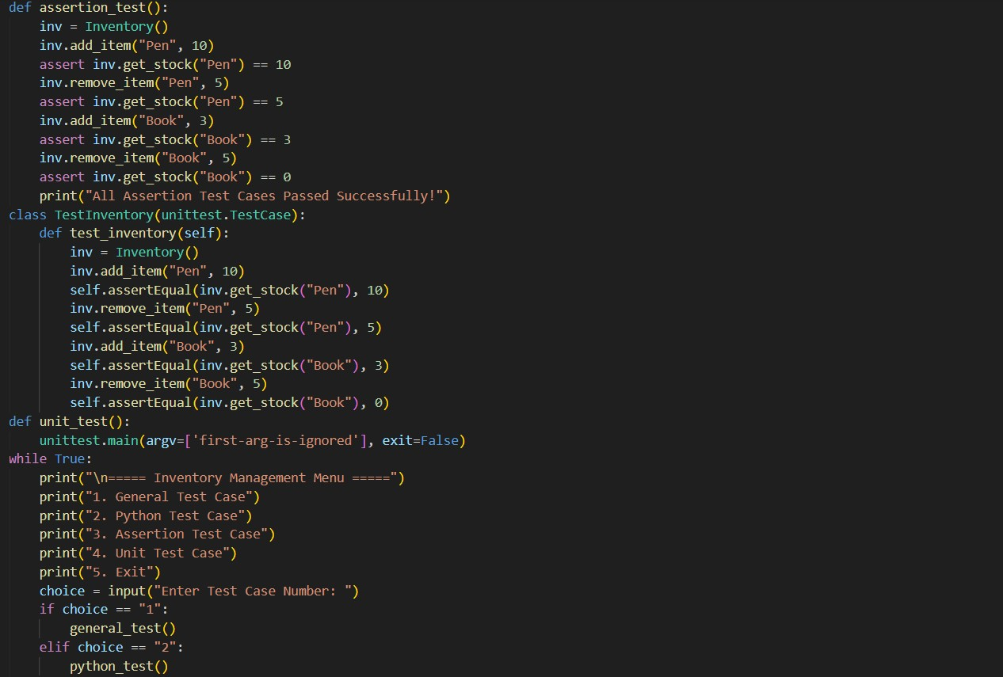
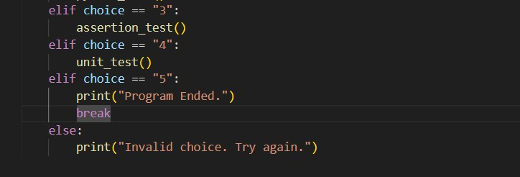

1.General test case
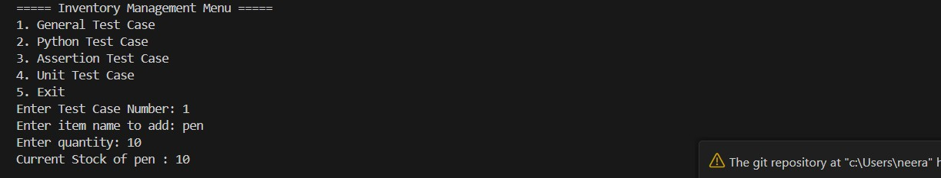

2.Python test Case
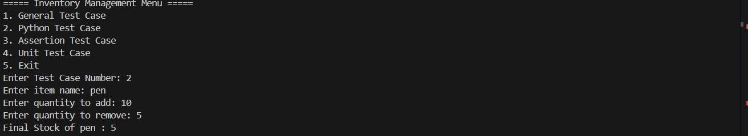

3.Assertion test Case
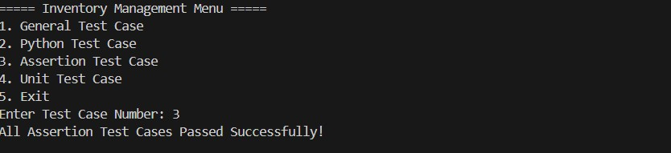

4.Unit test Case
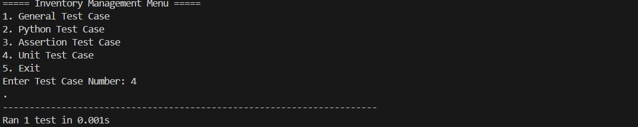

Task Description #5 (Date Validation & Formatting – Apply AI for Data Validation)
- Task: Use AI to generate at least 3 assert test cases for validate_and_format_date(date_str) to check and convert dates.
- Requirements:
o Validate "MM/DD/YYYY" format. o Handle invalid dates. o Convert valid dates to "YYYY-MM-DD".
Example Assert Test Cases:
assert validate_and_format_date("10/15/2023") == "2023-10-15" assert validate_and_format_date("02/30/2023") == "Invalid Date" assert validate_and_format_date("01/01/2024") == "2024-01-01" Expected Output #5:
• Function passes all AI-generated assertions and handles edge cases.

PROMPT
Generate a Python function validate_and_format_date(date_str) that validates dates in
"MM/DD/YYYY" format, converts valid dates to "YYYY-MM-DD", handles invalid dates, and includes at least 3 assert test cases to verify correctness.

CODE
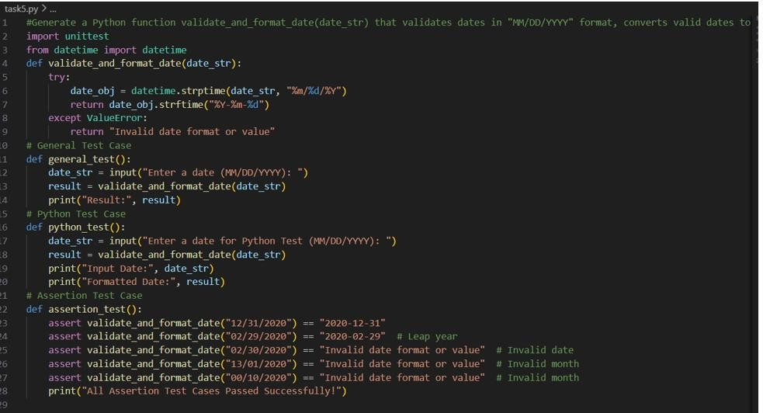
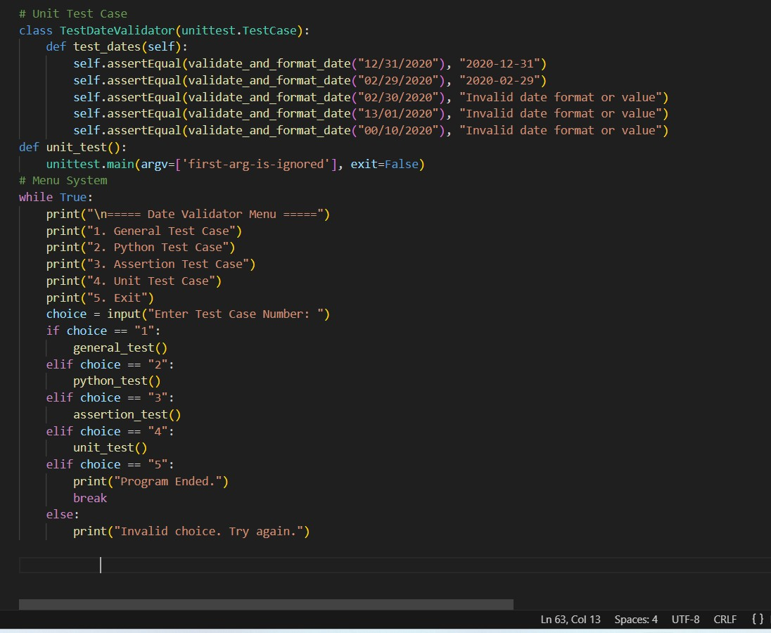

1.General Test Case
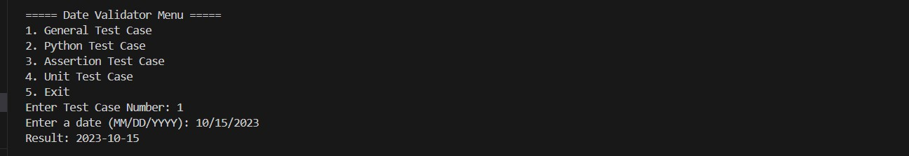

2.Python Test Case
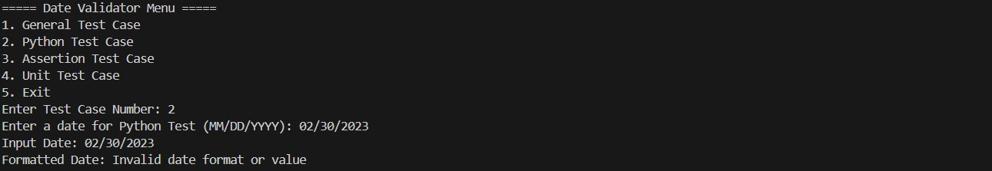

3.Assertion Test Case
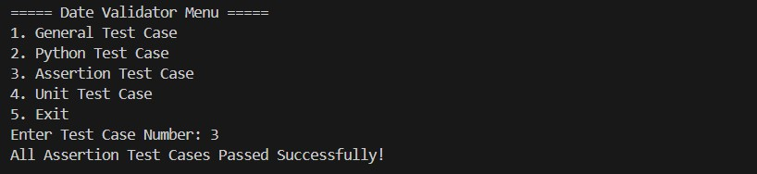

4.Unit Test Case
